Expanded Learning Opportunities Program Plan

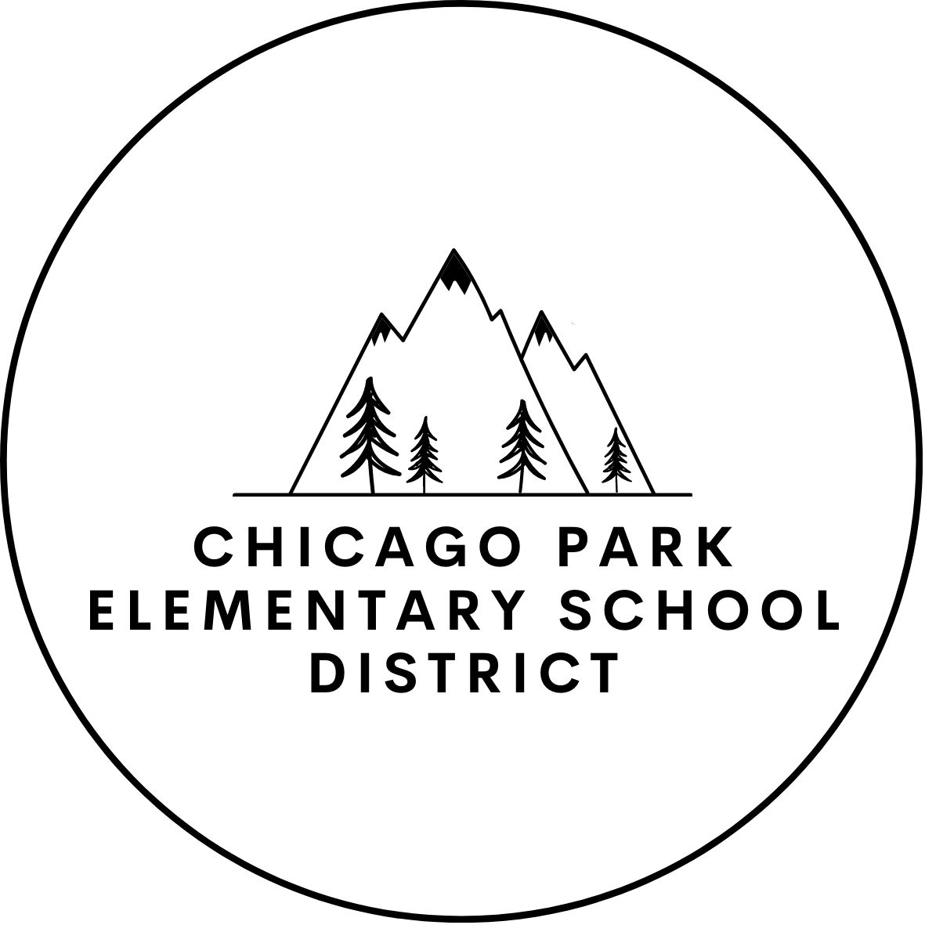

Prepared by:
Chicago Park School District
15725 Mount Olive Road
Grass Valley, Ca 95975
(530)346-2153

This Program Plan Template Guide is required by California Education Code (EC) Section 46120(b)(2)
Local Educational Agency (LEA) Name Chicago Park Elementary School District
Program Lead Katie Kohler, Superintendent
Contact (530)346-2153 ext. 202
katiek@chicagoparkschool.org
Site Chicago Park Elementary School
Purpose
This program plan is required by EC Section 46120(b)(2). In this program plan, we will describe program
activities that support the whole child, and students' Social and Emotional Learning (SEL) and development.
Definitions
"Expanded learning" means before school, after school, summer, or intersession learning programs that focus
on developing the academic, social, emotional, and physical needs and interests of pupils through hands-on,
engaging learning experiences.
It is the intent of the Legislature that expanded learning programs are pupil-centered, results driven, include
community partners, and complement, but do not replicate, learning activities in the regular school day and
school year. (EC Section 8482.l[a])
"Expanded learning opportunities" has the same meaning as "expanded learning" as defined in EC Section
8482.1. "Expanded learning opportunities" does not mean an extension of instructional time, but rather,
opportunities to engage pupils in enrichment, play, nutrition, and other developmentally appropriate activities.
(EC Section 46120[e][l])

Instructions
This Program Plan needs to be approved by the LEA's Governing Board in a public meeting and posted on the LEA's website.
The program plan is considered a living document that is periodically reviewed and adjusted to reflect the needs of the community, updates in the law, and to provide continuous improvement in the development of an effective ELO-P.
The LEA is responsible for creating, reviewing, and updating the program plan every three years in accordance with EC Section 8482.3(g)(l). LEAs are encouraged to work collaboratively with partners and staff to develop and review the program plan. The LEA is responsible for the plan and the oversight of any community partners or subcontractors. The LEA should include any partners in the development and review of the plan. It is recommended that the plan be reviewed annually.
The Expanded Learning Division adopted the Quality Standards for Expanded Learning in California (Quality Standards) and introduced requirements for Continuous Quality Improvement (CQI) to help programs engage in reflection and be intentional about program management practices and activities delivered to students. To create the program plan, provide a narrative description in response to the prompts listed under each Quality Standard below. The LEA may customize and include additional prompts, such as describing SEL activities, or refining the plan. In addition to the narrative response, it may be useful to include tables, charts, or other visual
representations that contribute to the understanding of the ELO-P. LEAs are encouraged to download and reference the Quality Standards in order to provide ongoing improvements to the program. The Quality Standards can be found on the California Department of Education's (COE) Quality Standards and CQI web page, located at https://www.cde.ca.gov/ls/ex/qualstandcqi.asp.

1 – Safe and Supportive Environment
Describe how the program will provide opportunities for students to experience a safe and supportive environment. Include if the program will be offered on the school site or off campus. If not on site, describe where in the community it will be and how students will be supported to get there.
Programmatic Level
Our number one goal in service to students every day is safety.
Response
The Expanded Learning Program will take place on our school site. Since we are a small rural district, our students are transported by their parents in private transportation.
Transporting Students
Expanded Learning- Before and After School
No transportation is needed as students are already on campus. The program, which takes place before the school day starting at 8:00 AM and after the school day will begin immediately upon dismissal of the instructional day and operate until 5:00 PM.
Expanded Learning- Summer School (based on funds)
Our summer program will take place on the Chicago Park Elementary/Chicago Park Community Charter campus. Students will be transported by parents via private vehicles.
Field trip transportation will follow the same guidelines in place for all District sponsored trips.
Attendance/Sign-ins/Sign-outs
When students arrive at the program whether it is before school, after school, or in the summer learning program, they will be personally greeted by staff and checked into the program. Program attendance will be collected and records will be maintained. At the end of the program students will be released either from the classroom(s) or the Multi-Purpose Room, depending on program, student will be physically handed over to a responsible adult and the adult must sign them out. In the event that funding for busing becomes available, students who are bused will be taken to designated bus stops and follow directions from their parents, either
walking home from there or being met by a responsible party. TK and K students MUST be met by a parent.
Facilities Safety
Our school site is well maintained and inspected and meet all current building codes and specifications for public school campuses.
We have ample lighting for additional safety precautions. Due to COVID-19, we have also implemented all safety precautions currently recommended by the California
School site has a safety plan that is updated annually. This plan outlines all of our policies and procedures as well as people responsible. To ensure that we operate in coordination with this plan, we participate in frequent drills and practices so that the students and teachers and staff are well aware of all procedures and practices well in the event of an emergency.

Staff Level
Behavior/Expectations
We incorporate a "shared responsibility" approach to our positive behavior supports and reinforcement for our students. These expectations have been created with a collaborative effort between students, teachers, classified staff members and Administrators.
Being a Responsive Classroom district enables us to:
- Effectively teach appropriate behavior to all children by identifying expectations and modeling and practicing these with our students.
- Intervene early before unwanted behaviors escalate-remaining alert and proactive so that we are not pushed into reactive mode.
- Use research-based, scientifically validated interventions whenever possible-work on strategies and behavior plans and be willing to reset and try something new if these are not working.
- Monitor student progress-remain actively engaged with each student every day to ensure they are receiving the support they need to be successful.
SEL Supports
At the school site, we personally greet students every day as they enter our campus (this is done by a combination of our classified staff, our certificated staff, our principal/superintendent, and our counselor).
This practice will be carried over into the expanded learning program by our program facilitators, program leads and program assistants.
We employ a School Counselor and a School Psychologist who work closely with our staff to support the mental health and well-being of all of our students. We also have our Special Education Director and classroom aides on campus to assist, advise and consult with our staff to assist all students in being successful. They will often meet to create behavior plans and expectations and share strategies and resources to assist in the best possible procedures for serving our students.
We believe, and research indicates, that addressing student social and emotional needs not only improves their mental health but also their social skills and their academic performance. It is with this in mind that we have increased our services to students in addition to purchasing curriculum to help serve our students diverse needs.
Participant Level
Community Building
Students and staff intentionally work together to build a shared community. This is evident in the time that our staff spends intentionally communicating one on one and in small group settings with our students. Our staff and other members of the community know each and every one of our families, their extended families and their siblings. In our small community it is very important to keep consistent, open, calm communication at the forefront of every interaction with staff, students and parents. We feel that the most important thing that we can do each and every day is to pause long enough to listen to a child. They are the reason that we are here.

2 – Active and Engaged Learning
Describe how the program will provide opportunities for students to experience active and engaged learning that either supports or supplements, but does not duplicate, the instructional day.
Programmatic Level
The design of our program and what will make it a quality program is making certain that we are offering opportunities for our students to learn and grow, beyond what they can do in the instructional day. It will also offer a very safe and trusted environment for them while their parents work or take care of other business. From the inception of our program we will continually ask for parental, staff, and student input as to what they would like the program to look like. Each of the activities will be designed based on their input. In order to gauge interest in activities we will have the parents sign the students up and to rank the offerings. This will allow us to make certain we are offering enough spaces in relation to the interest of our participants. We also know because we are located in such a rural area that our families depend on us to keep their children safe and engaged. The Superintendent/Principal will be an active participant in supporting this program. They will have frequent and open communication with the activity leader to ensure the mission and goals are being achieved.
Response
The Expanded Learning Program will not replicate the instructional day, however it is important to work together with shared goals, a shared culture, and shared expectations for our students, this helps them to feel safe, be able to anticipate what is expected and acknowledge the shared goal of serving their needs. The programming is divided into three main components:
- Instructional intervention, homework support and tutoring tailored to the individual needs of students. This will help meet our goal of adapting our program to the identified needs of our students who enroll.
- Physical education and sports; and
- Enrichment activities.
To continuously improve and develop the program we will continue to review and refer to the Quality Standards for Expanded Learning
Expanded Learning- Before and After School
The half-hour before school and three-hours after school program will begin with physical activities and sports providing a nice transition from instructional day to the expanded learning program. This time will be followed by a healthy snack for each child. Then, groups of 15-20 students will transition between individualized or small group instruction, academic support and an enrichment activity. Each of the program components will last 45 minutes to one hour. During academic support, activity leaders group each student in the appropriate group according to class assignment or intervention need. If leading intervention, the activity leader will use curriculum provided by instructional day while the other students work on homework or an activity of their choice from a menu provided by staff. During the enrichment programming activity leaders will lead students in a variety of lessons that include hands-on, real-life problems/solutions, that allow students to explore, investigate, research and create.
Expanded learning- Summer/Holiday Break School
Our Summer/Holiday (Winter Break) School program is a 30 day program operating for up to five days a week for six weeks. This program will be expanded in both number of days in operation as well as number of hours based on additional funds from the ELO-P funding. The program structured activities from 8 AM to 12 PM daily with the campus open from 7:30 AM- 12:30 PM. (5 hours). This will be expanded to operate 7:30 AM-4:30 PM (9 hours) in the upcoming years based on funding.
Our program is open to all students, however, English Language Learners, Homeless and Socio-economically students are prioritized.
Our goal is to design a program that is robust and includes the required educational and literacy element in which tutoring or homework assistance is provided in the following areas: language arts, mathematics, social studies, and science.
In addition, the design is to have an educational enrichment element that may include, but need not be limited to, agriculture, fine arts, career technical education, recreation, and physical fitness.
We look to offer a variety of different options and opportunities based on student interest surveys and parent feedback from previous programs. Examples of the activities that we will look to have the students engage in are:
- Makerspace: where students can create, invent, explore and discover using a variety of tools and materials.
- Cooking- where students use skills such as:
  - Reading skills: following directions, new vocabulary, sequencing
  - Math Skills: measurement, math calculations, fractions, temperature and shapes
  - Health lessons: healthy eating, food groups, safety and cleanliness
  - Fine motor skills: sifting, measuring, kneading, pouring, sifting, rolling, whisking
  - Social skills: cooperation, working together, teamwork, responsibility, sharing, self-esteem
  - Chemistry and Science: making predictions, chemical reactions, how temperature impacts gases, liquids and solids.
- Sewing: Similar skills are learned here as cooking since the students learn to use patterns, measure, cut sew and create their own items.
- Art: Students are able to use a variety of mediums to design and develop unique creations (paintings, murals, watercolor, oil pastels, posters, ceramics just to name a few).
- Agriculture: Students will be able to work and maintain the current garden areas including the orchard, vegetable garden, pollinator garden and greenhouse, as well as, the chicken coop. Students will be able to design and research temperature, soil conditions and plant types that will survive, grow and thrive in our climate.
Staff level:
The majority of staff in our before and after school and summer expanded learning program will also work in the instructional day. This will provide the opportunity for continual, open communication about students' needs and desired supports.
Participant Level:
Our entire campus will be open to our expanded learning programs. They are an extension of what we do to provide support to our students and their families. We will allow them access to any resource or materials they need including our library, our technology, our playgrounds and sports materials.

3 – Skill Building
Describe how the program will provide opportunities for students to experience skill building.
Programmatic Level
Response
All enrichment opportunities in the program will be designed to inspire creativity and innovation, we will work to increase critical thinking and problem solving, by using constant and meaningful communication and collaboration these goals can be achieved. The activities and lessons will be designed to support students at their current level of performance and move them towards mastery of skills they have not yet mastered.
Continuous collaboration and input will be facilitated between the Expanded Learning Program and the instructional day staff because the Expanded Learning Program will not replicate the instructional day, however it is important to work together with shared goals, a shared culture, shared expectations, diverse and dynamic learning modalities and time that will help us move outside of the limitations that can bind the instructional day.
Expanded Learning- Before and After School
There are a few activities that we are able to introduce and support in the instructional day but may not receive the time or attention needed to support mastery. In expanded learning, we can work collaboratively with the instructional day to increase the depth of learning and the level of performance of our students.
Expanded Learning- Summer/Holiday Break School
Our summer/holiday break program will be an enrichment intensive focused program that provides very diverse experiences that allow students the time and support to learn new skills, invest time in building mastery and gaining confidence and then showcasing these skills at the end of the session in various culminating activities dependent upon the skill. These culminating activities may be a talent show, an open house, a carnival with student created booths and games. All of these opportunities will be presented to students for them to decide what they would like to do as they are instrumental in developing the program and providing the activities.
Staff level
In supporting students and helping to move their learning forward they have the ability to practice skills. They can also offer coaching and positive feedback. They are able to spend time with students and offer support as they move through the inevitable experiences of trying, failing, reflecting and growing from our experiences. The supportive, open and caring relationships that they have developed will help them be a trusted adult for the students to rely on. Staff will be specifically hired and retained for their character that they exhibit when working with our students. We know that we can teach people how to teach, coach, do crafts, etc., but we cannot teach them to care.
Participant level
The activities and events that are integrated in both the expanded learning after school and summer program will provide support to engage students in 21st Century skills. They will have numerous opportunities to work collaboratively in multi-age groups that help them build higher level communication skills. They will also have
the opportunity to showcase their projects and their talents in various venues throughout the academic year and the summer.
21st Century Skills
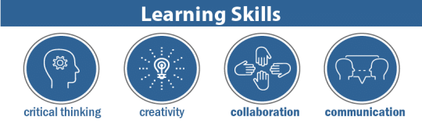
More educators know about these skills because they’re universal needs for any career. They also vary in terms of importance, depending on an individual’s career aspirations.
- Critical thinking: Finding solutions to problems
- Creativity: Thinking outside the box
- Collaboration: Working with others
- Communication: Talking to others
They’re sometimes called IMT skills, and they’re each concerned with a different element in digital comprehension.
- Information literacy: Understanding facts, figures, statistics, and data
- Media literacy: Understanding the methods and outlets in which information is published
- Technology literacy: Understanding the machines that make the Information Age possible
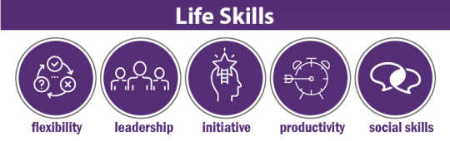
Also called FLIPS, these skills all pertain to someone’s personal life, but they also bleed into professional settings.
- Flexibility: Deviating from plans as needed
- Leadership: Motivating a team to accomplish a goal
- Initiative: Starting projects, strategies, and plans on one’s own
- Productivity: Maintaining efficiency in an age of distractions
- Social skills: Meeting and networking with others for mutual benefit

4 – Youth Voice and Leadership
Describe how the program will provide opportunities for students to engage in youth voice and leadership
Programmatic Level
Response
Student Leadership and voice is an integral part of our program. With the help of our ASB Advisor, we hope to develop a very active student council team. Our advisor(s) mentors these students and helps them to develop and refine their skills and to develop essential character traits including: responsibility, respect, trustworthiness, fairness and caring. As the students work and grow in these skills, they use their new found knowledge and empowerment to influence others. These students will be very instrumental on our campus in a variety of ways including our ELO-Program. They will help promote the program, they may help mentor younger students, they will help sponsor and support activities and they may also serve as "big buddies" or "peer tutors".
Staff level
Expanded Learning- Before and After School
The staff in our before and after-school program will be very intentional in making certain that our students have the opportunity to share their opinions, express their desires and take on leadership tasks. The students will be provided choice related to what the program offerings will be, what activities they would like to participate in and how they will celebrate their learning. As we continue to grow and establish our program, we intend to replicate the phenomenal work that is happening with our student leadership team and create an expanded learning leadership team with multi-age group representatives and leaders who will then help support the other students engaged in the program. These activities and experiences are exceptionally well suited to prepare students for moving into high school and working on Link Crew and Student government.
Expanded Learning- Summer/Holiday Break School
As in the after-school program we will work to continue to grow and increase the student's leadership facilitation and application of key learning. Again, as we continue to grow and establish our program, we intend to replicate the phenomenal work that is happening with our student leadership team and create an expanded learning leadership team with multi age group representatives and leaders who will then help support the other students engaged in the program. These activities and experiences are exceptionally well suited to prepare students for moving into high school and working on Link Crew and Student government.
Participant level
The use of our formal and informal means of collecting data related to program offerings allows the students the opportunity to provide feedback, participate in discussions and participate in developing the program. During the summer program students will enjoy the ability to spend extended time on self-selected activities, taking responsibility for completing projects and participating in culminating events that help them show what they know.

5 – Healthy Choices and Behaviors
Describe how the program will provide opportunities for students to engage in healthy choices and behaviors. Describe how students will be served nutritious meals and/or snacks during the ELO-P hours of programing.
Programmatic Level
Response
We are committed to helping our students and their families develop and promote healthy lifestyles. We spend a great deal of time in our instructional day making certain that every grade level from TK to 8th grade have access to regular physical education classes to support them in skill building and practice. This provides multiple options so that students can explore and learn new skills, try new sports and experience success. Additionally, we offer a sports program in which our 4th-8th grade students participate in seasonal leagues all year long with other schools. One of the greatest attributes of this program is that all students participate and have the ability to learn and grow. It is evident in our culture that fitness and nutritious eating and promotion of a healthy lifestyle is important. This culture will be carried into our after school and summer school program by actions, intentional learning opportunities and activities. Our policies will reflect the intent of our program which is to support our students in developing, learning and continuing to live a healthy lifestyle.
Expanded Learning- Before and After School
Active and engaged learning is the hallmark of our program. Snacks that are served to the students in the program also follow the national school lunch nutrition guidelines that apply to all food items served at school. In addition to learning about positive behaviors students are also instructed in and encouraged to learn responsible behaviors related to things to avoid in their lives that could negatively impact them such as tobacco, drugs, vaping, and alcohol.
Expanded Learning- Summer/Holiday Break School
In addition to the aforementioned aspects of the program and our culture, we will also have options for students to participate in gardening as well as cooking and nutrition classes.
Staff level
Our staff will model healthy living and the professionals we bring in will support that goal.
Participant level
Each activity that we participate in encourages our students to make healthy choices and to extend their learning beyond just the program.

6 – Diversity, Access, and Equity
Describe how the program is designed to address cultural and linguistic diversity and provide opportunities for all students to experience diversity, access, and equity. Describe how the ELO-P will provide access and opportunity for students with disabilities.
Programmatic Level
Response
Expanded Learning- Before and After School
Communication is vital to our success and we use multiple means to communicate with our small community at all times. We use our Facebook pages, our websites, phone calls/emails through our Student Information System, hard copy notifications, and the use of our marquee. Expanded learning staff will maintain current contact information for all students enrolled or interested in enrolling in the program so that they can contact them at all times. All promotional materials for any application, program openings or events will also be advertised in all of the above ways.
We welcome all students interested in enrolling in the program into the program. If students have any special needs, we make sure to have open communication so that staff are well aware and provided resources for serving those students. The only time a child is not immediately enrolled in the program is when we are limited by having enough staff to support our staff to student ratios.
Our staff is also very representative of the students that we serve. In such a small community, we often hire either family members or former students of our school.
Expanded Learning- Summer/Holiday Break School
The Expanded Learning Summer program will also be open to all students. Our program will celebrate diversity and welcome all students. Our program will be open to all and focused on meeting our mission and vision of supporting all students and supporting their growth while appreciating their diversity.
Staff level
Staff are well trained to serve all students.
Participant level
Our focus is on building relationships with our students and creating a safe space for them to feel comfortable and thrive.

7 – Quality Staff
Describe how the program will provide opportunities for students to engage with quality staff.
Programmatic Level
Response
Rigorous recruiting is done throughout the community by a variety of methods. We post flyers in the office and send out announcements via previously mentioned digital platforms. We also have made significant increases to the salaries and hours for the program to make the positions more enticing.
Due to our rural location all of our applicants come right from our school community and most are related to our families or are siblings who have already graduated from our school so they definitely reflect our students, staff and parents. We purposefully seek to hire individuals who exhibit integrity, professionalism, caring and work to be positive role models.
Staffing is accomplished by hiring a combination of Classified and Certificated staff members. All staff have had their finger prints cleared by both FBI and DOJ (Department of Justice).
Expanded Learning- Before and After School
Classified & Certificated:
Completed a variety of training via Public School Works that range from Mandatory Reporter Training to CPR.
Expanded Learning- Summer/Holiday Break School
Classified & Certificated:
Completed a variety of training via Public School Works that range from Mandatory Reporter Training to CPR.
Staff level
Staff are clearly identified with staff IDs and lanyards that identify them as staff members.
Staff will be made aware of grant requirements and work to maintain all assurances. Staff will check in weekly with the District Administration to ensure open communication and adherence to grant requirements.
Participant level
While our participants do not have a part in our staff selection process their input would definitely be considered if we ever had a problem with a staff member. Our staff, as previously mentioned are often part of our instructional day staff as well so they have very positive trusting relationships built with our students.

8 – Clear Vision, Mission, and Purpose
Describe the program's clear vision, mission, and purpose.
Programmatic Level
Response
The program’s mission and vision are a reflection of our district’s mission and vision.
Expanded Learning- Before and After School & Summer/Holiday Break School
Our district’s mission is to provide a well-rounded program that prepares students for 21st century success in all areas of academics, and by offering unique and individualized services in math, science, technology, and character development. We emphasize a safe and nurturing environment, and graduate responsible students who respect the rights of others.
We are open to all students and families committed to our mission/educational vision. The District honors the uniqueness of each individual, welcoming students from diverse backgrounds in order to build a strong, inclusive community and prepare all students for lives in a multicultural society.
The district offers specialized programs in Science, Math, Technology, and Character Development. Our schools emphasize good citizenship through a hands-on character development program that is integrated into the core curriculum.
We are committed to maintaining high expectations for academic, social and personal performance. Maintaining a small and supportive school environment is a top priority.
The primary purpose of the ELO-Program is to support those goals.
Staff level
The staff are the instruments for achieving our goals. The training, planning, focus, and work done by the staff will lead the students where they need to be. Through surveys, assessments, data-meetings, communication with parents and students, the staff will refine the mechanisms of the program to achieve the districts’ goals.
Participant level
Students will experience the outcome of our mission and vision without the need to teach it. If our program functions correctly, the outcomes mentioned in the mission and vision will manifest themselves in the products the students produce.

9 – Collaborative Partnerships
Describe the program's collaborative partnerships. Local educational agencies are encouraged to collaborate with non-LEA entities to administer and implement ELO-P programs.
Programmatic Level
Response
Our greatest effort for collaboration is among the school staff and the program staff to ensure that we are all working together to serve our students. Over the years we have developed several partners who we continue to work with as well as some new partnerships that we are working to increase. Support of the local School Board of Trustees and teachers is a vital piece to the success of our program. Communicating and celebrating the great work that is going on there to support our families is important.
Expanded Learning- Before and After School & Summer/Holiday Break School
Summer School as well as the instructional day program work with the same collaborative partners in support of our students.
Our partners include, but are not limited:
- Duckies
- Sierra Harvest
- Gold Country Kuk Sool Won
- Nevada County Master Gardeners
- Artist Workshop
- Cast Hope
- Pigeon Point Light Station State Historic Park
- Swasey’s Hardware & Hobbies
- Samba Soccer
- 4-H
- Girls and Boy Scouts
Staff level
Communication is a vital part of our program and our school community as a whole. We employ multiple means of communicating with our parents, our staff, and our community. We use our Facebook and Instagram pages, our website, phone calls/emails, hard copy notifications, and the use of our marquee.
Participant level
Students will be very instrumental in sharing what these partnerships will mean to their program. They will be invited to the Board meeting to share activities, they will share with the instructional day staff and we all share the same spaces so this will create a seamless transition from instructional day to expanded learning with our students, our families, our staff, and our community partners.

10 – Continuous Quality Improvement
Describe the program's Continuous Quality Improvement plan.
Programmatic Level
Response
We have a long history of using a quality improvement cycle to develop, implement, review and adjust our systems as we work to provide the best possible services to our students. In addition to data driven decision making we are also committed to providing a program that serves the needs of our community, our families and our students.
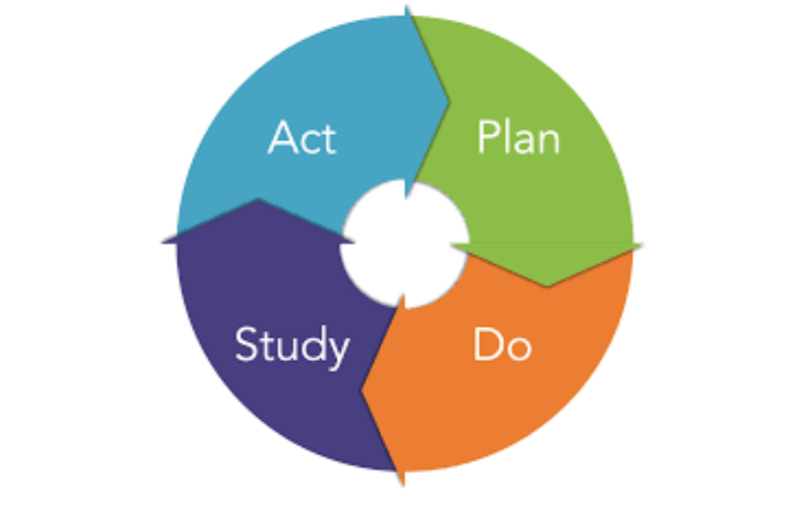
Continuous Quality Improvement Cycle
Collect data on the program using multiple strategies. Data comes from sources including self-assessments, review of program policies and manuals, interviews and surveys conducted with staff, youth, and other stakeholders, and observation of program activities.
Reflect on program data and use data to generate and implement an action plan for program improvement. Action plans can be used to revise and refine organizational strategies and goals, to direct organizational resources towards areas that need improvement, and to guide professional development for staff.
Implement the action plan, taking time to reflect on progress along the way. Once key goals are met, reassess and update the action plan accordingly.
Expanded Learning- Before and After School & Summer/Holiday Break School
Both programs will follow the same data driven assessment outlined above.
Staff level
The expectation is that staff will be very reflective and communicative. Staff will regularly collect necessary data required for the management of the program. They will also commit to continuous improvement.
Participant level
We will develop a formal process for obtaining student input specifically related to our program once it has been implemented for a significant portion of time and has the capacity to increase services. Moving forward we will continue to ask for input and use it to develop our program.
11 – Program Management
Describe the plan for program management.
Programmatic Level
Response
This program is dependent upon open and frequent communication between the staff, the lead certificated intervention specialist, and the Superintendent/Principal.
All fiscal management is done by the CBO using the SACS coding system and tracked in our budgeting software, Escape.
The program will be overseen by the Superintendent/Principal, who will make staffing decisions, evaluate effectiveness, and monitor the budgeting.
Expanded Learning- Before and After School
Staffing for the Before School program will be as follows:
- ELO-P Aide to work 8:00AM to 8:30AM
Staffing for the After School program will be as follows:
- TK ELO-P Aide to work 12:40 PM to 5:00 PM
- ELO-P Aide to work from 1:45 - 5:15 PM
- ELO-P Aide to work from 2:45 PM to 4:30 PM
- ELO-P Supervisor Contracted through Duckies
- Community partners as budget allows
Expanded Learning- Summer/Holiday Break School
Staffing for the Summer School program will be as follows (based on funding):
- ELO-P Aides
- Teachers
- 7 hours of secretarial support per day
- Administrator
- Community partners as budget allows
Staff level
Planning
Staff will meet prior to beginning of program to participate in team building, review all policies and procedures and expectations. Staff will be provided with lanyards so that they are easily identifiable on campus and can be seen.
Training
Staff will also attend at a minimum one full day of training prior to the beginning of any sessions (example: School year/Summer/Intersession)
Regular Staff Meetings
Staff meet each morning or afternoon of the program to go over the daily plans and materials prep.
Communication
All staff have Walkie talkies while on campus so that they can communicate amongst themselves and call for assistance if needed.
Managing student information
Student information will be available via our student information system Synergy as well as hard copy for quick access.
Professional Development
Additional Professional Development will be provided throughout the school year based on staff observations and need.

Transitional Kindergarten and Kindergarten
Programs serving transitional kindergarten or kindergarten pupils shall maintain a pupil to-staff member ratio of no more than 12 to 1. Please address the proposed schedule and plan for recruiting and preparing staff to work in the program, including supporting them to understand how to work with younger children. How will the lower pupil-to-staff ratio be maintained? How will the curriculum and program be developmentally-informed to address this younger age group?
Response
Our Transitional Kindergarten program currently operates on a half-day schedule, however, we already have supports in place for students who wish to stay later through onsite Childcare/Preschool. If we add additional TK classes, we will continue to staff in the same manner we currently do, but maintaining a 12:1 pupil to staff ratio. We will also be drawing upon the Preschool program on site to support the TK-ers during this time as they are the most experienced with this age range.

Sample Program Schedule
Expanded Learning – School Day (TK-3rd Grade)
8:00 AM - 2:00 PM Traditional School 12:45 PM-2:00PM Preschool/Duckies (TK only)
2:00 PM - 2:45 PM PE Activity
2:45 PM - 3:15 PM Nutritious Snack
3:15 PM - 4:00 PM Small Group Homework Support/Targeted Intervention 4:00 PM - 5:00 PM Enrichment Program
Expanded Learning - School Day (4th-6th Grade)
8:00 AM - 3:00 PM Traditional School
3:00 PM - 3:15 PM Nutritious Snack
3:15 PM - 4:00 PM Small Group Homework Support/Targeted Intervention 4:00 PM - 5:00 PM Enrichment Program
Expanded Learning - Summer School (K-8)
7:30 AM - 8:15 AM Breakfast/Morning PE Activity
8:15 AM - 12:00 PM Wheel Rotation
Wheel Element #1 - ELA Support
Wheel Element #2 - Math Support
Wheel Element #3 - STEAM Enrichment #1
Wheel Element #4 - STEAM Enrichment #2
Wheel Element #5 - PE Activity
12:00 PM - 1:00 PM Lunch + PE Activity
1:00 PM - 4:30 PM Student Choice Community Partnership Enrichment Activity (if funding allows)

